Test Document

Project : Flutter_Comments_Application

Document History :
Version | Date | Author | Comments/Change Description
1.0 | 05.09.2025 | Kavya Chokkalingam | Initial Testing Documention

Requirement :
To create a flutter app to post a comment and to check the existing comments

Technology and Tools :
Frontend : Flutter, Dart
Backend : Python with FastAPI
Database : SQLite
Version Control : Git, GitHub
IDE / Editor : VS Code
Others : Virtual environment (venv), Flutter DevTools

Test Cases
Test Case 1 :
- Check the flutter comments app in a web browser
Flutter app being opened in chrome.
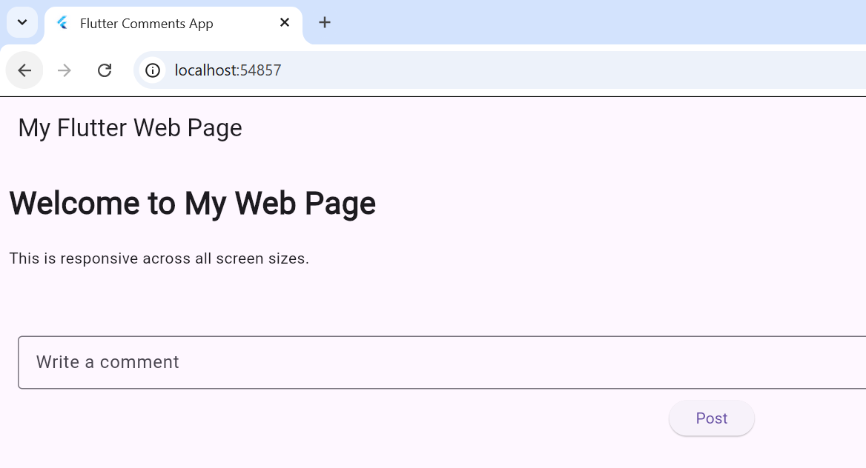

- Post a comment and refresh the webpage
Here, we can the comments the user has posted earlier
